Tell us what you think about elections in New Zealand
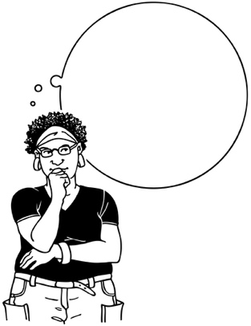
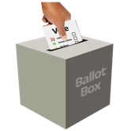

October 2022

Before you read this document

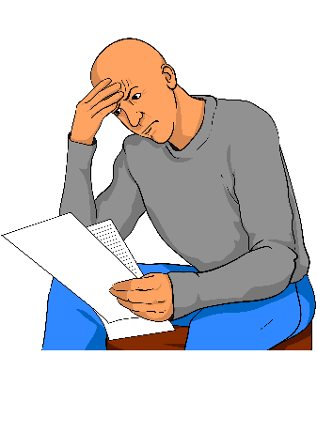

This is a long document.

While it is written in Easy Read it can be hard for some people to read a document this long.

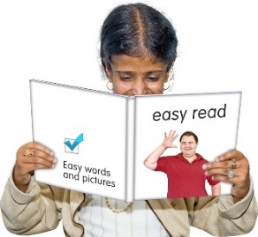
Some things you can do to make it easier are:

- read a few pages at a time
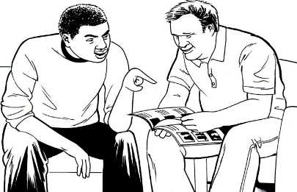
- have someone help you to understand it.

What you will find in here

Page number:

What is this document about? 5

Who is doing this review? 8

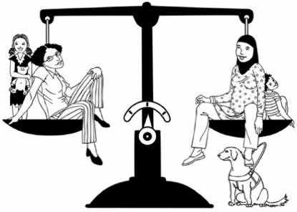

Why is this review important? 10

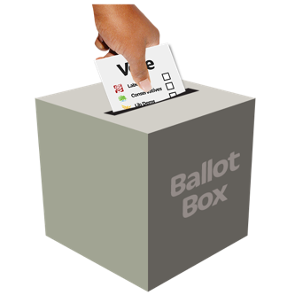
What is this review about? 14

Page number:

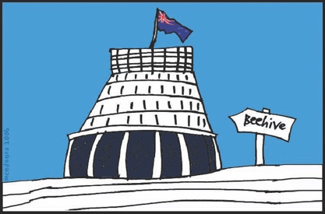
Part 1. Summary of information
about the electoral system in
New Zealand 19

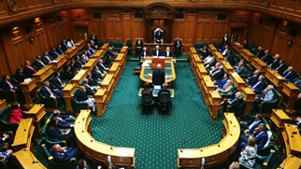

- The voting system 19

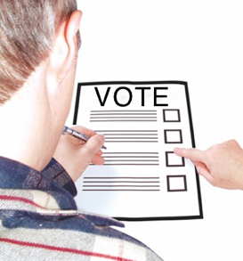

- Voters 27

- Parties and candidates 34

- Electoral administration 41

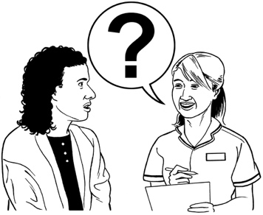
Page number:

How to have your say 46

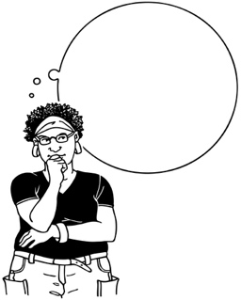
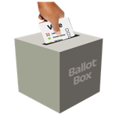
Part 2. Questions about the electoral system in New Zealand 51

- The voting system 52

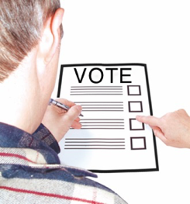

- Voters 55

- Parties and candidates 59

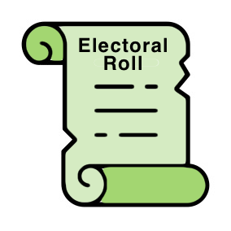
- Electoral administration 62

What is this document about?

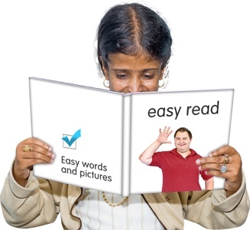
This Easy Read document is in 2 parts.

Part 1 is a summary of information about the electoral system in New Zealand.

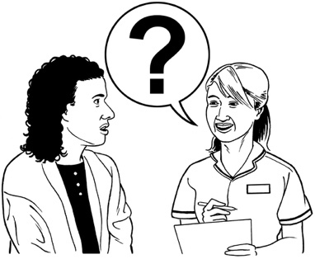
Part 2 is a list of questions we would like you to answer about the electoral system in New Zealand.

A summary:

- is shorter than a full report
- tells you the main ideas.

The electoral system is the laws / rules that set out:

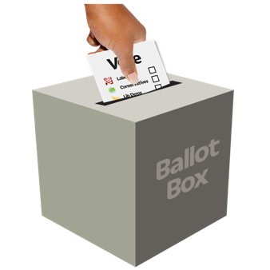
- how elections are run

- how the results of elections are determined.

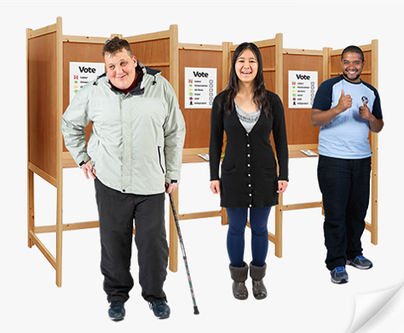
Elections are the times when you vote for the people you want to make important decisions about:

- things that affect how you live

- the country you live in.

When you vote you get to have your say about who you think should win an election.

Determined means that there are rules for how to make a decision.
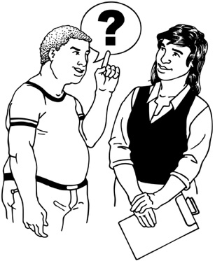
The questions in this document are part of a review called the Independent Electoral Review.

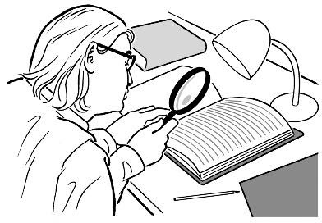
A review is when someone:

- looks at how well things are working now

- tries to find out how to do things better.

In this document the Independent Electoral Review is called the IER for short.

Who is doing this review?

The review was set up by the Minister of Justice.

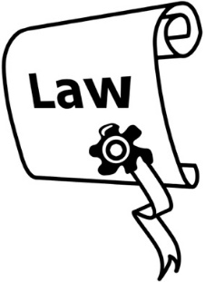
The review is looking at the election laws in New Zealand.

The review is a chance to make election rules:

- simple to understand
- fair for everyone

- easy / accessible for all voters.

Accessible means that everyone is able to vote in a way that suits their needs.
A group of 6 people called a panel are doing this review.

The IER panel is being led by Deborah Hart.

The other members of the panel are:

- Associate Professor Maria Bargh
- Professor Andrew Geddis

- Dr Lara Greaves

- Alice Mander

- Robert Peden.

You can find out more about the IER on our website at:

https://electoralreview.govt.nz/

Why is this review important?

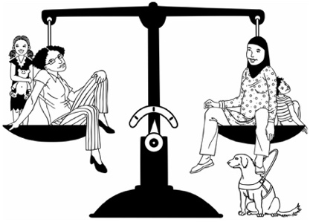
It is important that the electoral system of a country is fair for everyone who lives in that country.

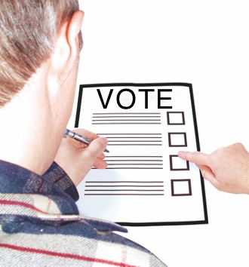
This is to make sure that everyone has an equal say about how their country is run.

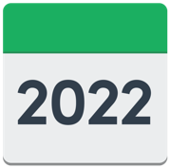
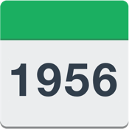
Some of the electoral laws of New Zealand have stayed the same for over 60 years.

This means some of these laws:

- are out of date

- may not be good for everyone who wants to vote.

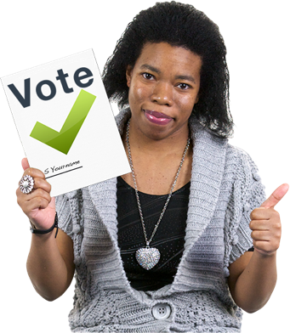
Changing our election laws gives us a chance to change how we hold elections to be much better in the future.

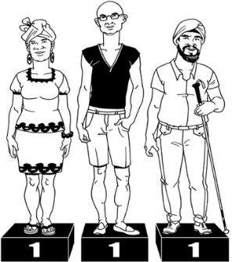
To make sure our electoral system is as good as it can be it should:

- be fair for everyone to use
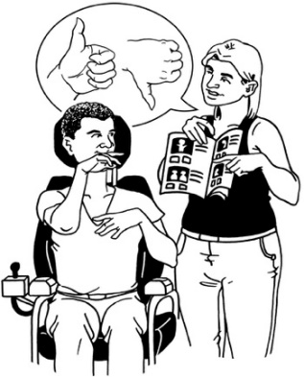
- be easy to understand

- not change without good reason

- be open to everyone

- make people feel like they want to vote.

Other ways we can make the electoral system as good as it can be are by making sure:

- it does what it is supposed to do

- it lasts for a long time

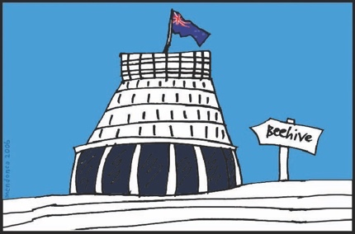
- the people who are voted into Parliament stand / speak for the people who voted for them

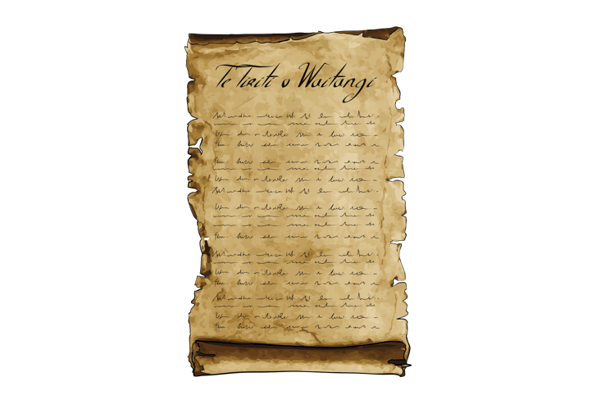
- it thinks about Te Tiriti o Waitangi / The Treaty of Waitangi.

Te Tiriti o Waitangi / The Treaty of Waitangi is an important document that was signed in 1840.

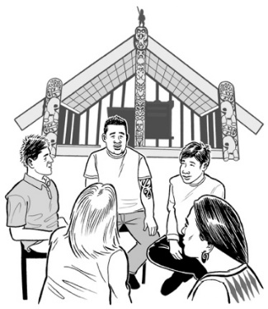
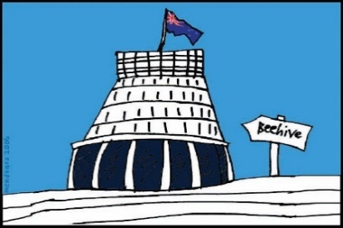
Te Tiriti / The Treaty is about Māori and the New Zealand Government:
- making decisions together
- protecting things that are important to Māori.

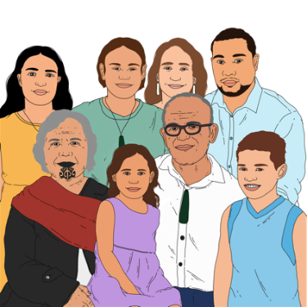
Te Tiriti / The Treaty promises Māori the same rights as all other people in New Zealand.

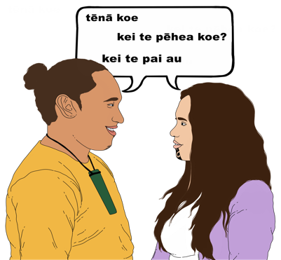
It is important that:

- Māori have a say about what happens in Parliament and electoral law

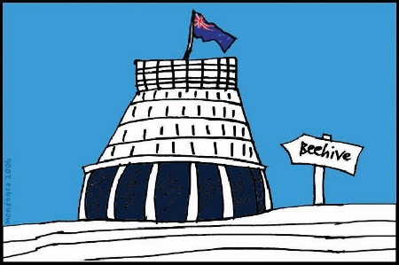
- Māori are listened to

- Māori can take an active part in elections and Parliament.

What is this review about?

The IER covers almost everything to do with how elections work.

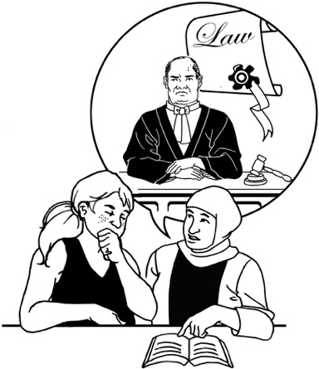
As they do the review the panel will look at how election laws are:

- thought about

- put into place

- become rules that everyone needs to follow.

The panel will also think about recommendations made by the:

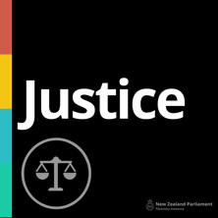
- Electoral Commission

- Justice Committee.

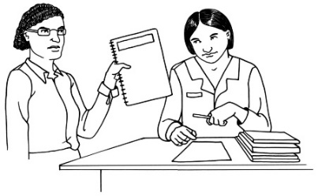
Recommendations are things that can be done to make things better.

The Electoral Commission is in charge of running elections.

The Justice Committee:

- is part of Parliament

- checks that the rules for elections are the best they can be.

The review will be done in 2 stages.

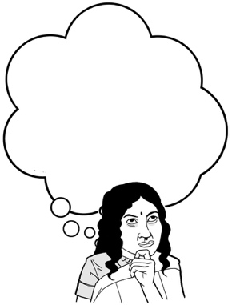
This means people in New Zealand will have 2 chances to share their thoughts about the electoral system with the panel.

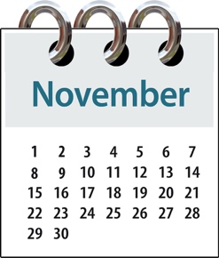
Stage 1 runs from now to 14 November 2022.

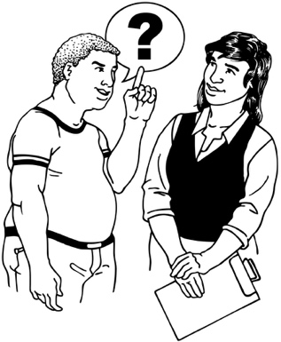
Stage 1 asks people what they think about the electoral system in New Zealand.

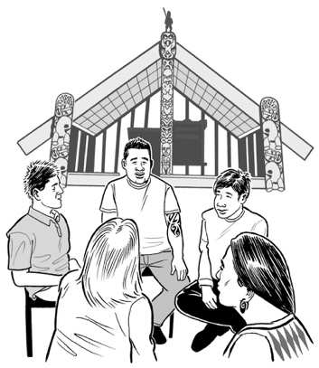
The panel is meeting with:

- Māori / iwi

- advocacy groups

- political parties.

The panel is also holding a number of public meetings.
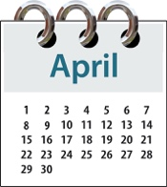
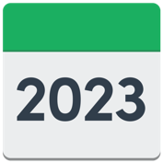
Stage 2 will begin in April 2023.

Stage 2 will give people another chance to say what they think after the review panel has made some recommendations.

The panel will give its final recommendations to the Government at the end of 2023.

There are some things about elections that the panel will not be looking at like:

- voting that is done online

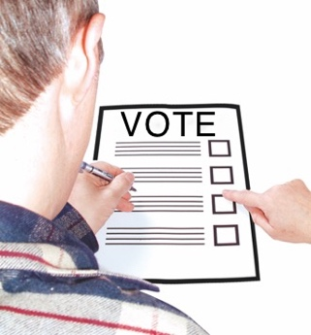
- different ways of electing people / political parties that are not used in New Zealand

- laws that are about local government elections.

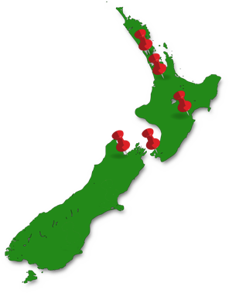
Other things about elections that the panel will not be looking at are:

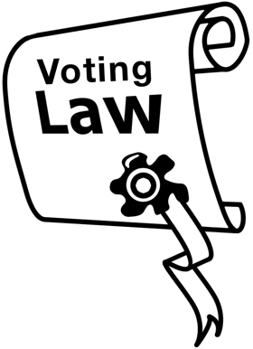
- voting areas that are called Māori electorates

- other issues about the way our government is set up.

A Māori electorate is a voting area in which only people who are on the Māori electoral roll can vote.

You can find out more about electoral rolls on page 27.

You can find more information about what things the review will look at on the Terms of Reference page of our website at:

https://electoralreview.govt.nz/

Part 1. Summary of information about the electoral system in New Zealand

The voting system

New Zealand uses a voting system called Mixed Member Proportional or MMP for short.

This voting system is used to decide who will be a Member of Parliament - an MP.

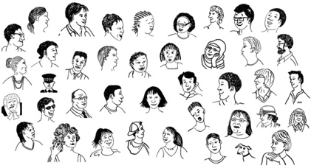
Parliament has 120 seats for its MPs.

A seat is another way of saying an MP has won a place in Parliament.

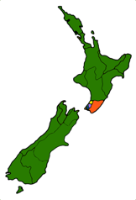
The MPs who have a seat in Parliament are made up of:

- MPs who represent their local area called electorate MPs
- MPs who represent their political party called list MPs.

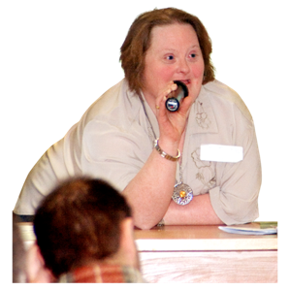
Represent means to stand / speak for someone.

Every political party tries to win as many seats as they can in an election.

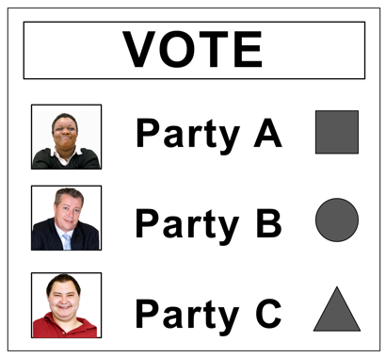
In the MMP system you get to make 2 votes:

- a party vote

- an electorate vote.
Your party vote means you get to:

- vote for a political party
- help decide how many seats in Parliament each party gets.

The political party / parties with the most votes gets to run the country.

Your electorate vote means you vote for the candidate in the area you live in.

The people you vote for in an election are called candidates.

The candidate with the most votes becomes an MP.

A party vote threshold is the smallest number of votes that a political party must win to get seats in Parliament.

To be able to get into Parliament a political party must win:

- 5 out of every 100 party votes which is known as 5 per cent
or

- at least 1 electorate seat.

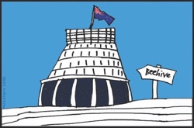
The 1 electorate seat threshold means that a party can get into Parliament even if they do not get enough party votes.

The review is looking at recommendations made by the Electoral Commission in 2012 that could make the MMP system better.

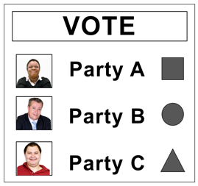
The recommendations are things like:

- changing how many votes are needed to win a seat in Parliament
- changing the ratio of list MP to electoral MP seats to make things fairer.

A ratio is a way of showing with numbers how 2 things are:

- linked in some way

- the same as each other

- different to each other.
The current ratio of seats in Parliament is 60 to 40.
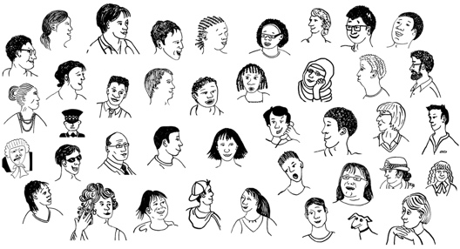

This means for every 60 electorate MP seats there are 40 list MP seats.

The Electoral Commission also recommended getting rid of overhang seats.

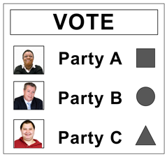
Overhang seats are extra seats a party can win in Parliament if it gets a lot of electorate votes.
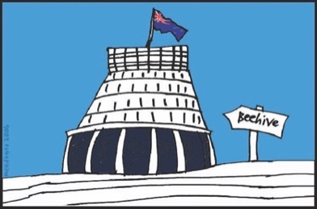

This part of the review will also look at the parliamentary term.

A parliamentary term:

- is how many years a political party gets to run the country

- lasts for 3 years in New Zealand.

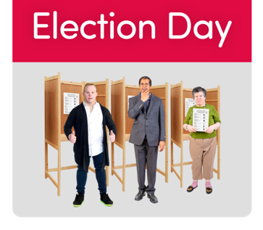
This means a general election happens in New Zealand every 3 years.
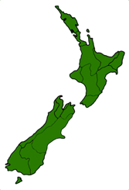
A general election is when you vote for who you think should run the country.

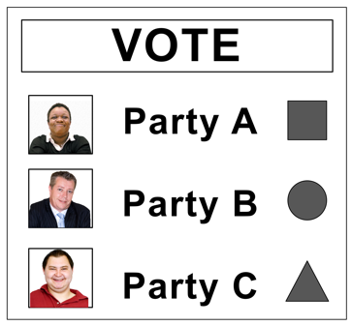
The person who leads the political party that wins a general election is called the Prime Minister.

The current Prime Minister of New Zealand is the Right Honourable Jacinda Ardern.

The Prime Minister can decide if they want to call an election at any time before the 3 years are over.

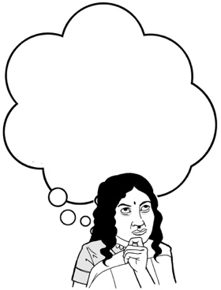
The review is looking at:

- if the amount of time between elections should be changed
- if there should be changes to how an election is called

- how an MP can lose their seat in Parliament

- what happens if an MP loses their seat.

Voters

Voting is a way for the people who live in New Zealand to have a say about how the country is run.

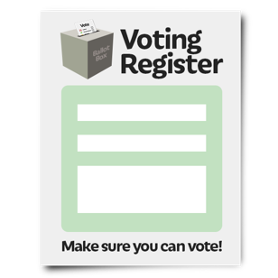
Your name must be added to the electoral roll before you can vote.

This is called being enrolled to vote.

The electoral roll is a list of all the people who have enrolled to vote.
It is split into 2 lists:

- the Māori roll that is open to voters who are Māori

- the general roll that is open to all voters.
No one can be on both rolls at the same time.

To get enrolled to vote in New Zealand you must:
18

- be at least 18 years old

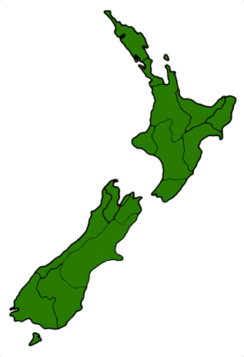
and

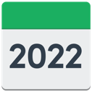
- have lived in New Zealand for more than 1 year at some time in your life

and

- be:

- a New Zealand citizen
or

- a New Zealand permanent resident.
A New Zealand citizen is someone who can get a New Zealand passport.

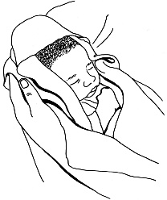
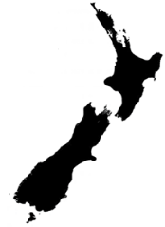
Many New Zealand citizens are born in New Zealand.
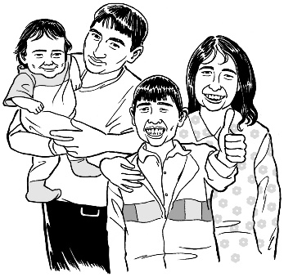

Some people who come to live in New Zealand from overseas also become New Zealand citizens.

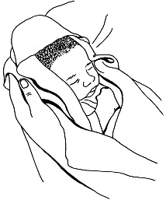
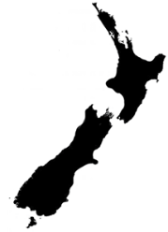
A New Zealand permanent resident is someone who:

- was not born in New Zealand
- has been told by the Government they can live in New Zealand all the time.
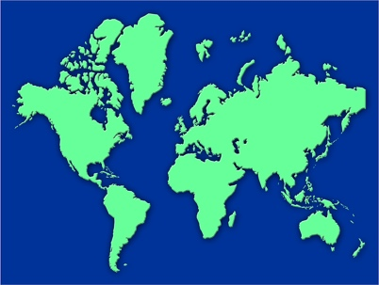
Some people cannot vote like:

- people who live overseas and have not come back to New Zealand for some time

- people who have seriously broken election laws
- people who must stay in prison for 3 years / more than 3 years.

The review is looking at:
18

- if the voting age should be changed from 18 years old

- if there should be any other changes to who can vote.

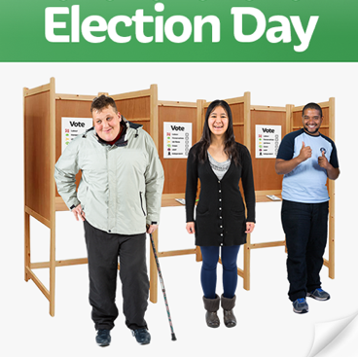
There are lots of different ways that people can vote like:

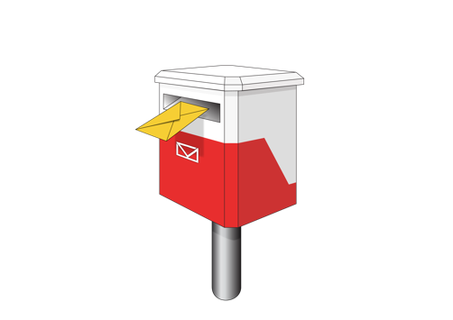
- voting in person on election day

- voting by post

- voting before the election day called advance voting.

The review is looking at if the current ways of voting are good for everyone who wants to vote.

The review is also looking at if current ways of voting:

- can be made better

- can be made more accessible for everyone.

The review wants to be sure that the voting system will still work well if:
- an emergency happens

- if something else happens that could affect how people vote.

An emergency is when something serious happens that means people need to act quickly to stay safe like:

- a pandemic like COVID-19

- a strong earthquake.

An emergency could mean that an election is put on pause until the danger is over.

The review will also look at things like:
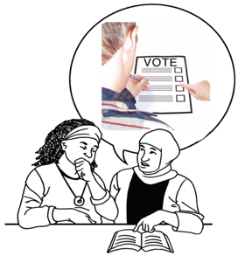
- making sure the way people vote cannot be affected by other things that might change their vote
- how the votes are counted

- how people are told about the results of the votes

- how people can enrol to vote

- which electoral roll people want to be added to.

Parties and candidates

The electoral system in New Zealand means that people can put themselves forward for others to vote for them if they are:

- a political party
- a candidate:

- for a party
- on their own.
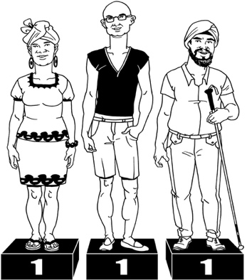

It is important that the rules of the electoral system are fair to everyone.

The rules must be fair for:

- choosing candidates
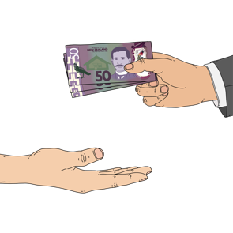
- getting / using any money as part of a political party
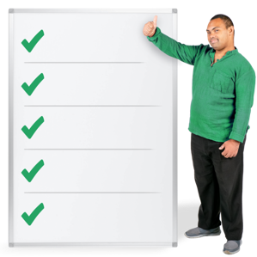
- getting political parties registered.

A registered political party is a party that:

- has enough members

and
- signs up with the Electoral Commission.

Anyone can start a political party
but

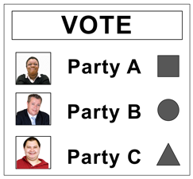
only political parties that are registered can put themselves forward for a party vote in an election.

Having lots of different political parties means that there are lots of choices for people to vote for.

You can be a candidate for election if:
- you are a New Zealand citizen

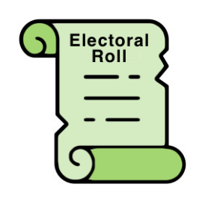
and

- your name is on the electoral roll.

You cannot be a candidate for election if you are a permanent resident.

The review is looking to see if any changes need to be made to:

- how political parties get registered

- who can be a candidate for election

- how candidates are chosen.

Political parties / candidates mostly fund their election campaigns with:
- their own money
- donations from other people.

A campaign is when a person /
a group of people does things to:

- make other people aware of what things they are doing

- reach a goal of some sort.
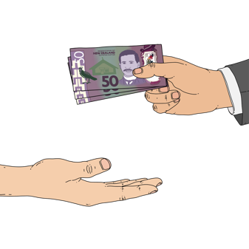

A donation is when someone gives money to another person / group of people that they support.

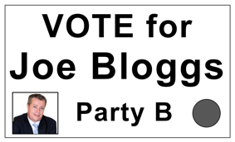
There is a small amount of public money that parties can use at election time to advertise what they do.

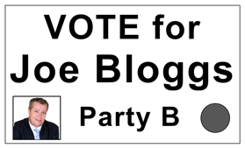
Advertise means to make people know about you / what you do in a way that makes them want to support you.

The review is looking at:

- how political parties get their money
- how political parties use private / public money

- if the rules about political party money should change.

There are strict rules on how much money a political party can spend on advertising.

This is to keep things fair / equal for all the parties.

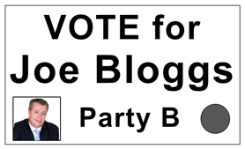
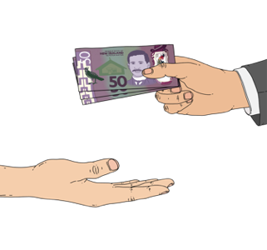
The review will also look at how political parties show where their money comes from.

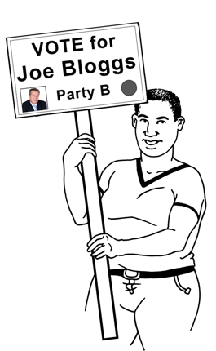
The review is also looking at if there needs to be any changes to:

- how political parties can advertise
- when political parties can advertise.

Electoral administration

Administration means the group of people in charge of taking care of something.
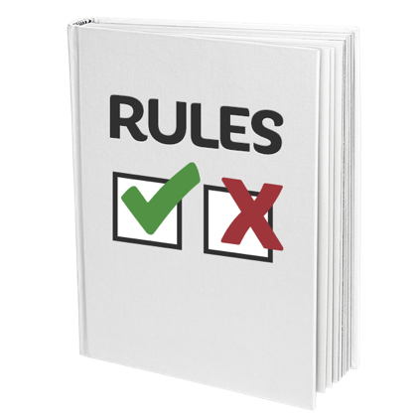

A number of groups look after the electoral system in New Zealand to make sure the rules are followed.

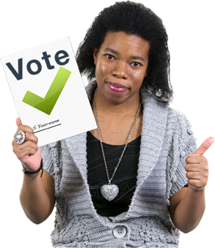
The Electoral Commission does things like:

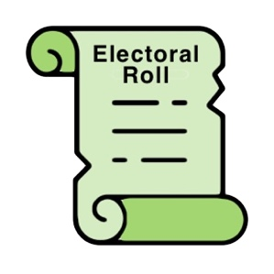
- making sure that elections go smoothly

- looking after all the electoral rolls
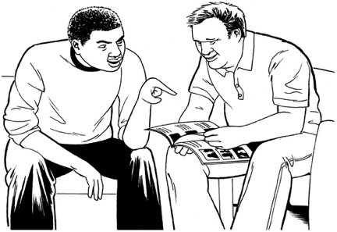
- offering support so people can learn about and understand the electoral system.

The review is looking at:

- what kinds of things the Electoral Commission does
- if any changes need to be made to the things the Electoral Commission does.

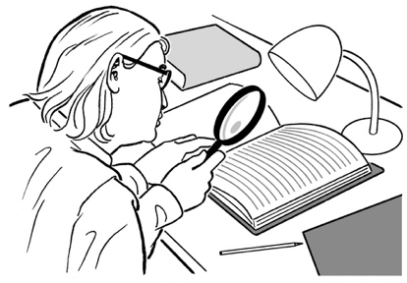
One of the jobs of the Electoral Commission is to:

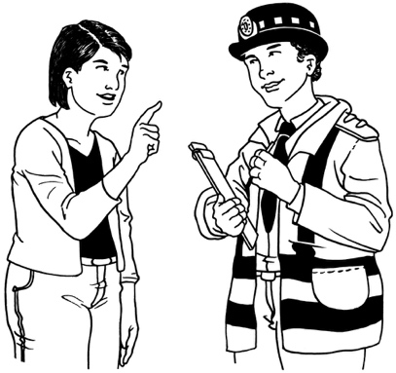
- watch to see if any electoral laws have been broken

- pass on information about any serious issues to the Police.

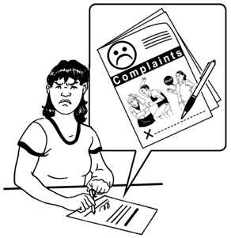
The review is looking at if any changes are needed in:

- how complaints are dealt with

- what happens if the law has been broken

- how the rules / laws are followed.

This part of the review will also look at:

- things to do with the electoral rolls like how they are used
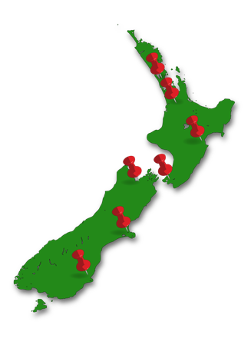
- how voting areas are decided.

This part of the review will also look at what other groups do to make sure the electoral system is working well like:

- the Police
- the Serious Fraud Office
- the Broadcasting Standards Authority

- the Advertising Standards Authority.

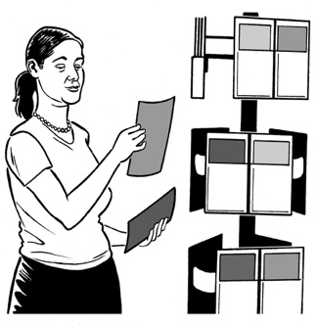
The review will also look at other things that might affect what party / candidate someone votes for like:

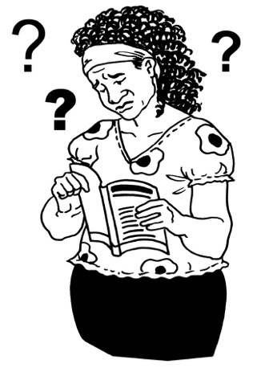
- election information that is known to be wrong

- election information that is put out in a way that is not clear / easy to understand with the aim of confusing people
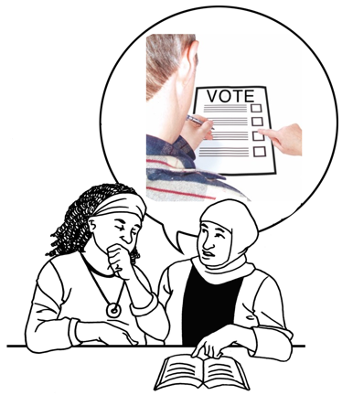
- things done by groups who are overseas / not in New Zealand that might change what happens in an election.

How to have your say

We want to know what you think about the electoral system.

We will use your views when we make recommendations about things that need to change.

You can find out more about what we want to do in the review at our website:
https://electoralreview.govt.nz

There is a list of questions we would like you to answer on pages 51 to 65 of this document.

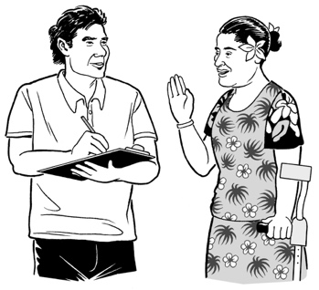
You can have your say on the review in a number of ways.

You can share what you think about the electoral system by filling in the form online at this website:

https://consultations.justice.govt.nz/policy/independent-electoral-review

You can also write to tell us what you think:

- by email to:

secretariat@electoralreview.govt.nz
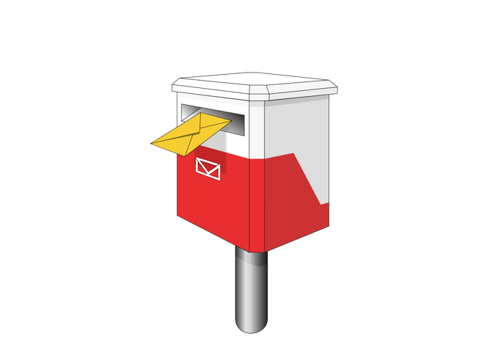
- by post to:

Independent Electoral Review
Free Post 113
PO Box 180
Wellington 6140
You can also send us a video to tell us what you think.

Please get in touch with us if you would like to send us a video.

Information about events where people can speak to the review panel will be put on our website at:

https://electoralreview.govt.nz
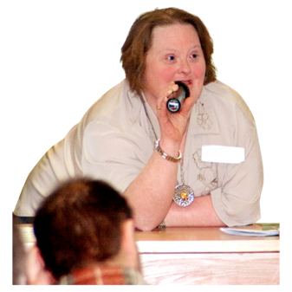

Please get in touch with us if you would like to speak to the panel.

You must tell us what you think by
14 November 2022.

We may not be able to look at anything sent to us after this date.
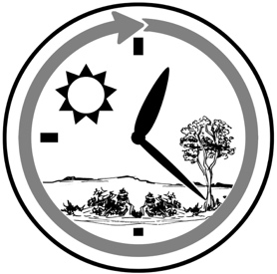
You should let us know if you think you will need more time to send us your views.

It is important you know that the panel may share any views / information it is given.

You must tell us if you do not want your views / information shared in this way like:

- your name
- any other information you give us.

The Official Information Act 1982 is a law that says people can ask us to share information you give us.

The panel must also make sure they follow the laws set out in the Privacy Act 2020.

This law says what the IER can do with any personal information you give to us like:

- how we get the information

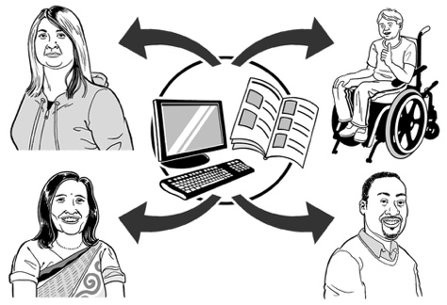
- how we use the information

- how we share the information.

You can at any time:

- look at the information we have about you
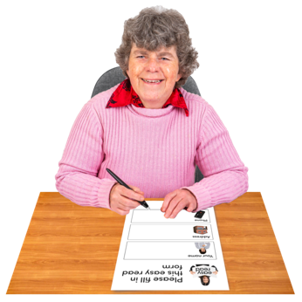
- make changes to the information we have about you.

Part 2. Questions about the electoral system in New Zealand

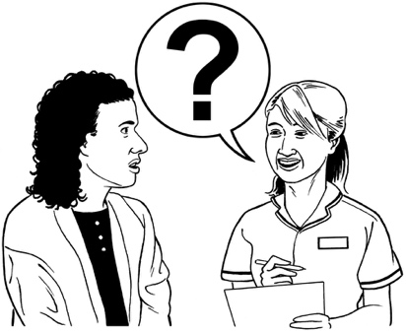

On the next few pages you will find a list of questions we would like you to answer about the electoral system.
You do not have to answer all the questions.

You can just tell us what you think without answering the questions if you want to.

Some of the questions ask what changes you think should be made to the electoral system.

If you do not think any changes need to be made it is okay to say no changes.

Some of the questions use hard words that we have talked about in part 1 of this document.

1. The voting system

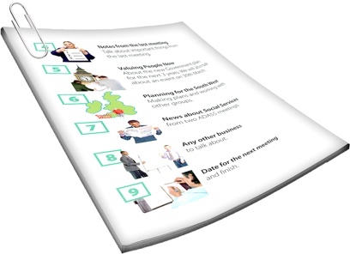
You can find more information about things the questions in this section talk about on pages 19 to 26 of this document.

1.1 What do you think the party vote threshold should be?
1.2 What do you think about the
1 electorate seat threshold?
1.3 What do you think about overhang seats?

1.4 Do you think:
- the ratio of electorate to list seats should be a fixed number
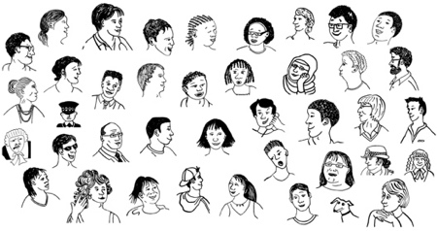
and

- what should that number be?

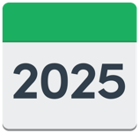
1.5 How long do you think a parliamentary term should be?

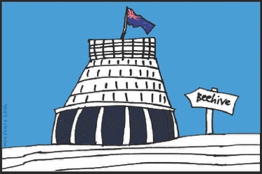
1.6 How do you think the Government should decide when the date for an election happens?
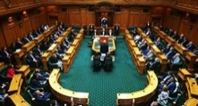
1.7 Do you think any changes should be made to the rules for:

- when an MP leaves their party / Parliament
and

- how to decide who takes their place?

Is there anything else you would like to tell us about the voting system?

2. Voters

You can find more information about things the questions in this section talk about on pages 27 to 33 of this document.

2.1 How old do you think people should be to be allowed to vote?

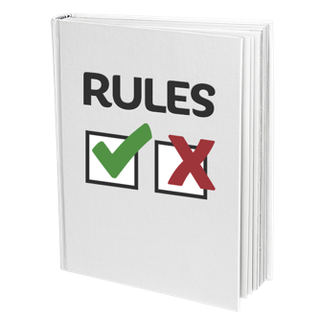
2.2 Do you think any changes should be made to the rules that say who is allowed to vote?

2.3 Do you think any changes should be made to how someone can get enrolled to vote?

2.4 Do you think any changes are needed for choosing to be added to the Māori electoral roll?

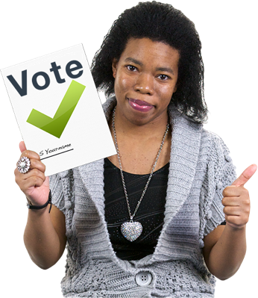
2.5 Do you think the current ways of voting:

- are good for everyone

- need any changes?

2.6 Do you think any changes need to be made to make sure voting is accessible for everyone?

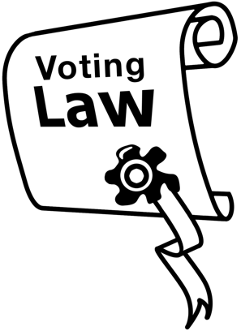
2.7 Do you think:

- the rules / laws in New Zealand about voting are good enough
- the way people can vote is secret enough?

2.8 Do you think any changes need to be made to how people vote:

- in times of an emergency

- other difficult times?

2.9 What kinds of things / events do you think should mean an election / voting is paused?

2.10 Who do you think should be able to decide if an election / voting gets paused?
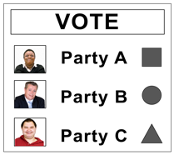
2.11 Do you think the way votes are counted could be made better?

2.12 Do you think:
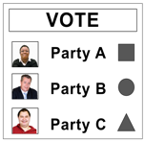
- the rules / laws about how votes are counted are good enough

- any changes need to be made to how votes are counted?

Is there anything else you would like to tell us about voters?

3. Parties and candidates

You can find more information about things the questions in this section talk about on pages 34 to 40 of this document.

3.1 Do you think any changes need to be made to how a political party is registered?

3.2 Do you think any changes need to be made to the rules about who can be a candidate?

3.3 Do you think any changes need to be made to the guidelines parties must follow when they choose their list MPs?

3.4 Do you think any changes need to be made to how candidates can be chosen?

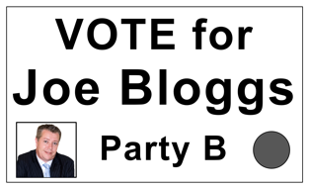
3.5 Do you think any changes need to be made to how political parties:
- get their money

- use their money?

3.6 How do you think political parties / candidates should get their money?

3.7 Do you think any changes need to be made to:

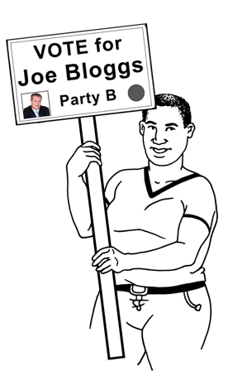
- any advertising done at election times

- rules about how political parties run their campaigns?

3.8 Do you think there should be any rules that say what election money cannot be spent on

and

who do you think the rules should be for?

Is there anything else you would like to tell us about parties and candidates?

4. Electoral administration

You can find more information about things the questions in this section talk about on pages 41 to 45 of this document.

4.1 What do you think about the things the Electoral Commission does?

4.2 What do you think about:

- how people can look at the electoral rolls
- how people can change their information on the electoral rolls

- how the electoral rolls are looked after?
4.3 Do you think any changes need to be made to how the areas of land that make up an electorate are:
- decided

- named?

4.4 Do you think any changes need to be made to:

- the kinds of things to do with voting / elections that are against the law

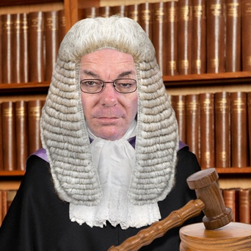
- what happens if someone is found to have broken the law about voting / elections?

4.5 Do you think any changes need to be made to rules that say what happens if people cannot agree on:
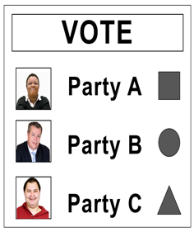
- things to do with voting

- who wins an election?

4.6 Do you think anything needs to be done to make sure elections in New Zealand are not at risk from:
- election information that is known to be wrong

- election information that is put out in a way that is not clear / easy to understand with the aim of confusing people?

  - Do you think anything needs to be done to make sure elections in New Zealand are not at risk from things done by groups who are overseas / not in New Zealand?

Is there anything else you would like to tell us about the electoral administration?

If there is anything else you want to tell us about the review please let us know.

You can find our contact details on page 46 of this document.

This information has been written by the Independent Electoral Review.
It has been translated into Easy Read by the Make It Easy service of People First New Zealand Inc. Ngā Tāngata Tuatahi.

The ideas in this document are not the ideas of People First New Zealand Inc. Ngā Tāngata Tuatahi.
Make It Easy uses images from:

- Changepeople.org
- Photosymbols.com

- Sam Corliss
- Huriana Kopeke-Te Aho

All images used in this Easy Read document are subject to copyright rules and cannot be used without permission.

